1. **Do search for web-site, http, URL etc given topics in lecture.**

Web site are combination of webpages identified as common domain name, HTTP stands for Hyper Text Transfer Protocol is worldwide used webpage loader from hyper links , URL stands for Uniform Resource Locator .URL contains protocol (HTTP),domain name(www.amazon.com) and extension(/cart) [http://www.amazon.com/cart]

1. **Do search for domain, hosting, SEO etc.**

Domain is name for website or we can say company for the website like amazon.com which represents name of a company. web hosting is a service for store a data and host a website for clients and SEO mean Search Engine Optimization . it is used for to understand your content and help users to find your website.

***HTML***

**Are the HTML tags and elements the same thing? If not describe how?**

No, tags are only consist of <p></p> and element is with content inside it like

<p>this is content</p>

**What are void elements in HTML? With Example.**

void elements are those who can not contain any content inside it like br tag ,input tag etc

**• What are HTML Entities? With Example.**

Html entities are for there to represent sing emojies and marks like question mark smile emoji copyright sign and etc.

**• What are different types of lists in HTML? With Example.**

There are three types of lists in html 1 unordered list or bulleted list 2 ordered list or numbered list 3 description list or definition list

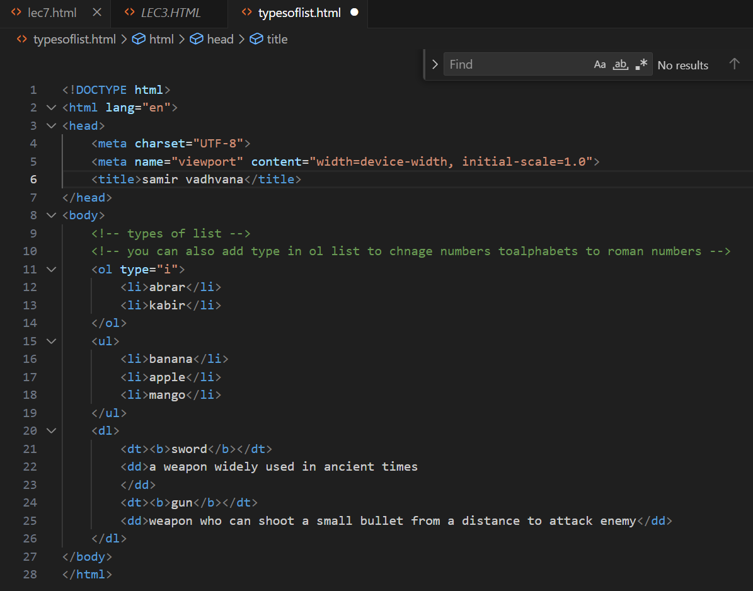

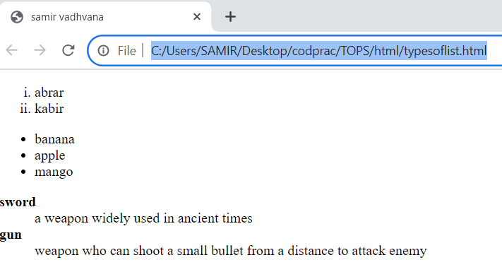

**• What is the ‘class’ attribute in HTML? With Example.**

Class attribute is used to specify one or more class names to give a same property or style lets see it with example

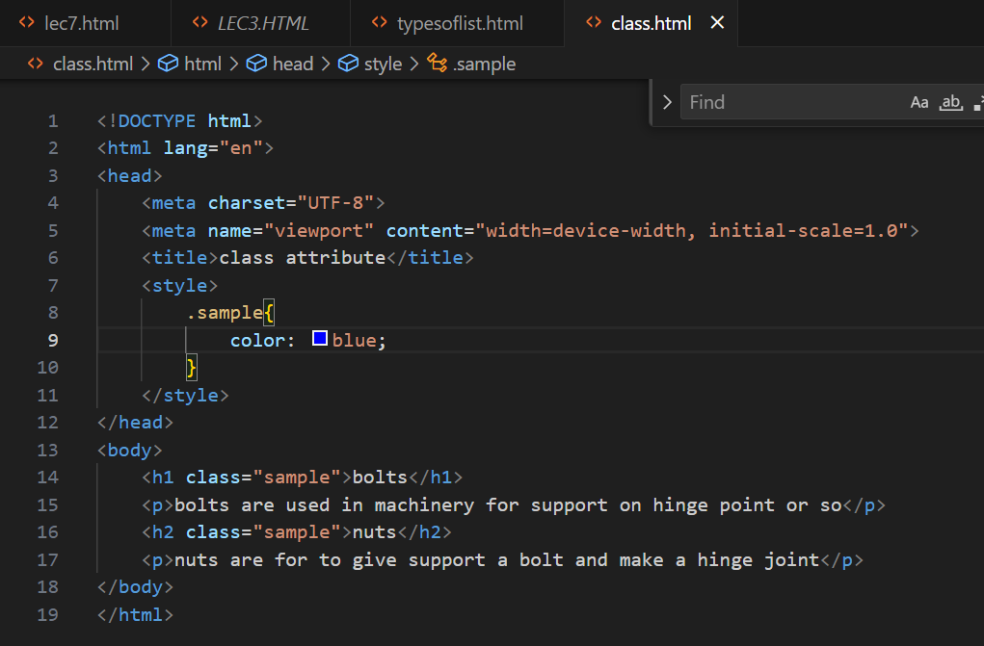

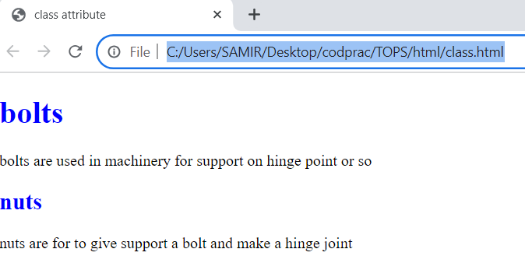

**• What is the difference between the ‘id’ attribute and the ‘class’ attribute of HTML elements? With Example.**

Id attribute is only used by one html element and class attribute is used by multiple html elements

**• What are the various formatting tags in HTML?**

There are so many formatting tags in html like bold italic underline and so on

Lets see it in the VScode

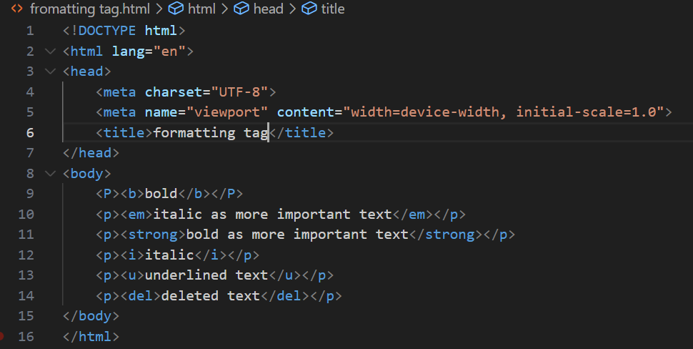

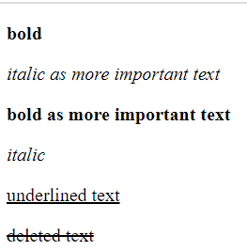

**• How is Cell Padding different from Cell Spacing? With Example.**

Cell spacing refers to space between two cells and cell padding is for space between text and cell inside that cell

**• How can we club two or more rows or columns into a single row or column in an HTML table? With Example.**

We can club two or more rows by rowspan and colums by colspan attribute

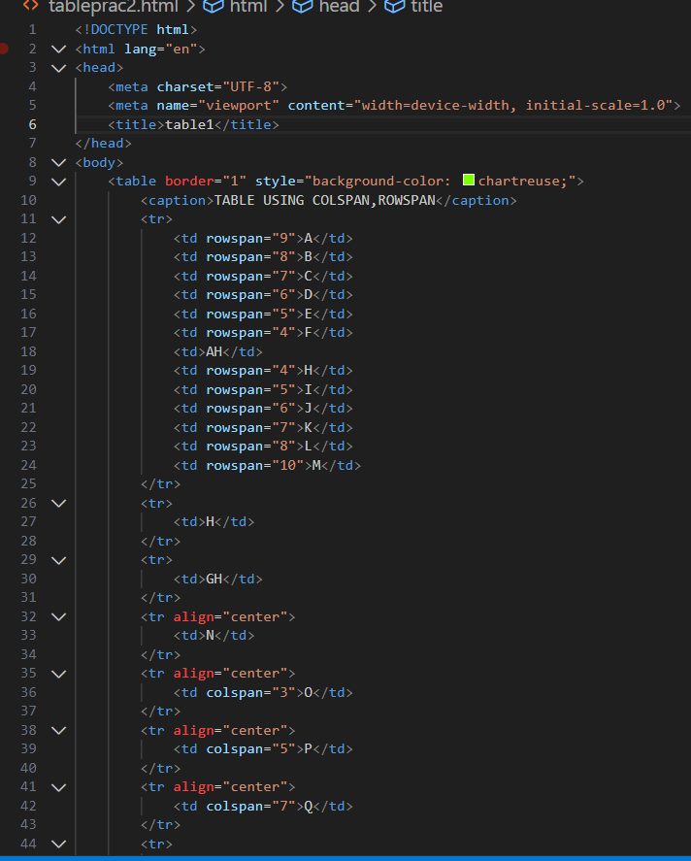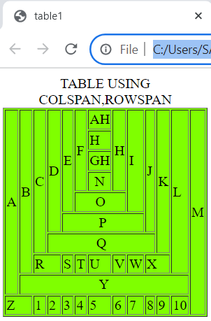

Like in above example ive used both rowspan and colspan for merging one or more colums and rows

**• What is the difference between a block-level element and an inline element?**

Block level elemet uses entire width of page whether it occupies it or not but inline element only occupies needed space. for ex. h1 to h6 all headings element are block level element and  **a** anchor tag or img tag are inline element example

**• How to create a Hyperlink in HTML? With Example.**

To create hyperlink in HTML we use **a** (anchor) tag

As in below example in href you enter link to reference page and name of link in tag as I mentioned it hyperlink you can name it as per requirement. By clicking on hyperlink the page will redirect me to amazon site as I mentioned

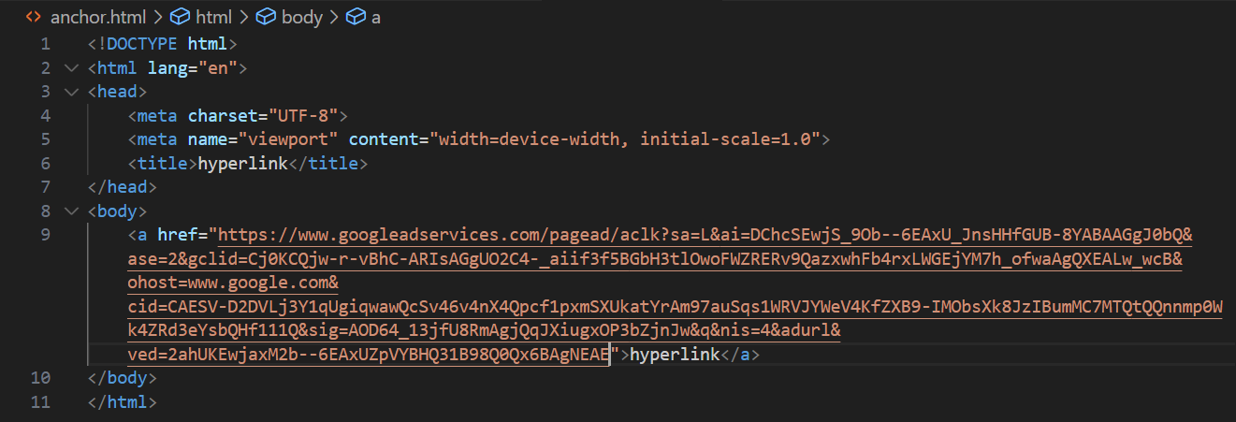

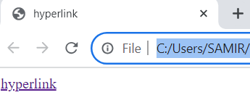

**• What is the use of an iframe tag? With Example.**

Iframe loads another HTML page in Document it is usually used to embedded videos or advertisements like…

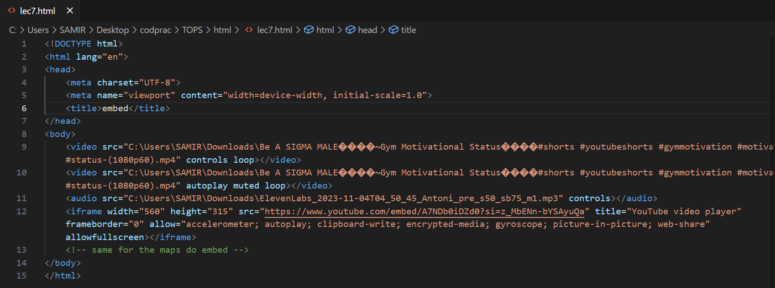

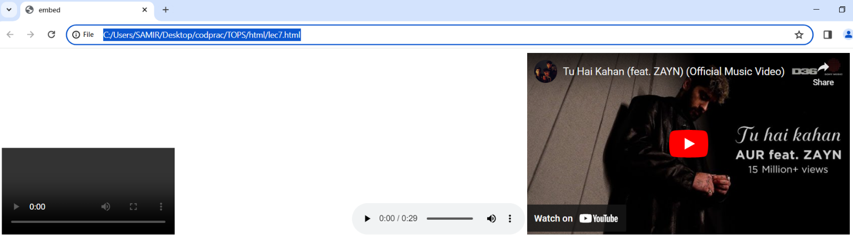

**• What is the use of a span tag? Explain with example?**

Span and div tag are likely same but span tag is inline element and div tag is block-level element . as you can see the difference of div tag and span tag also use of span tag in different ways below.

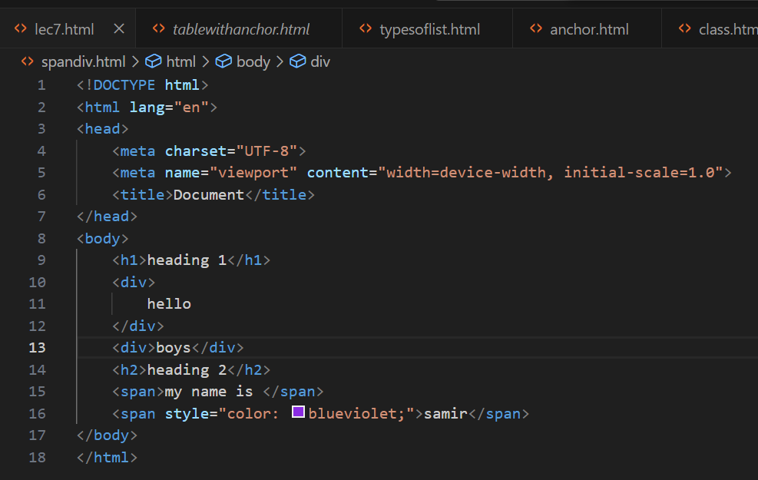

Span tag does not break line it allows user to change selected elements to chnage

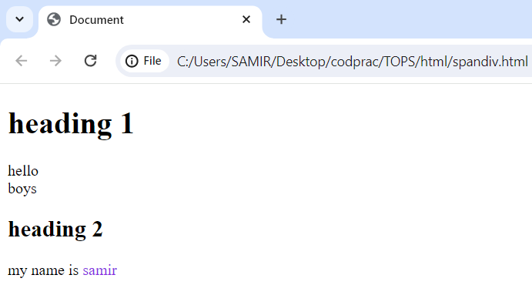

**• How to insert a picture into a background image of a web page? With Example.**

As there is 3 ways to apply css into html same way we can enter background image in three different ways 1st inline css by style atrribute and using background image property

2nd by using internal css by adding style element in head portion

And 3rd way is by using external css and link it to needed file

In folloeing example ive used all ways to describe how all ways work

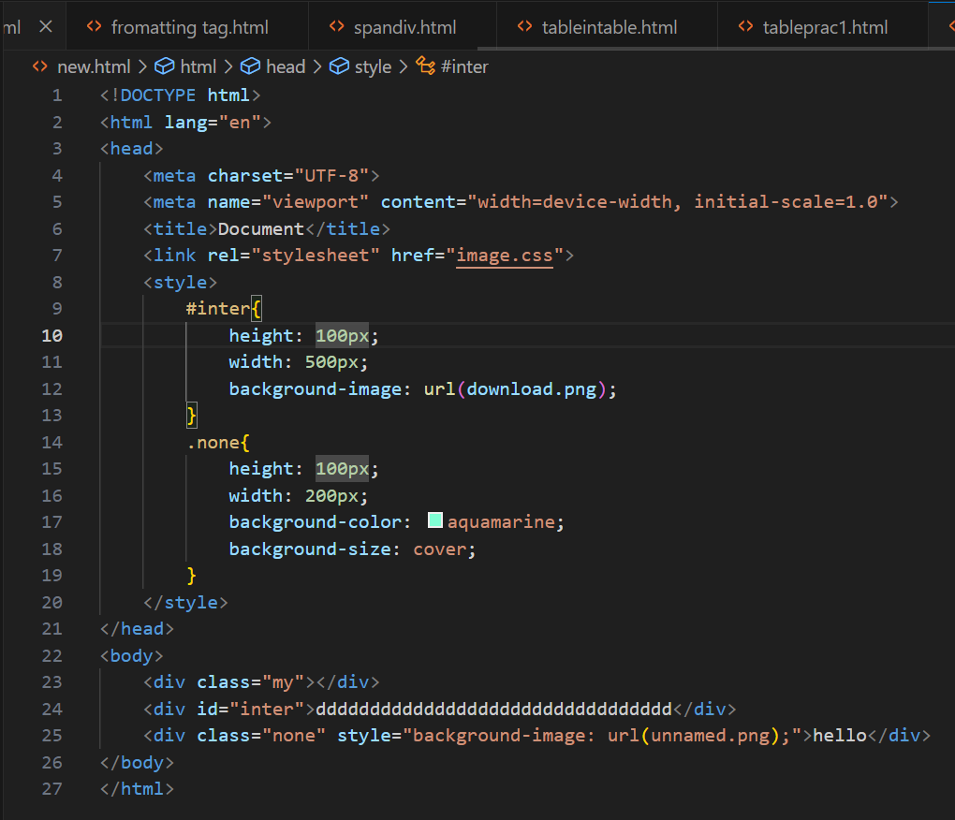

output

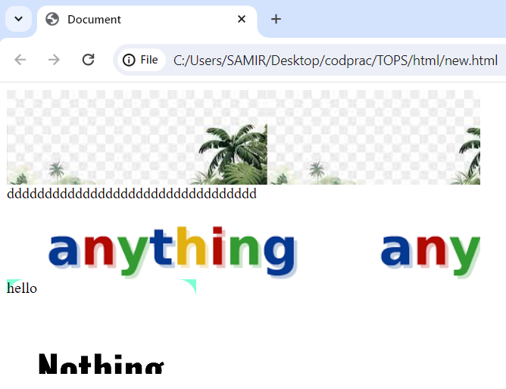

**• How are active links different from normal links?**

Active links are interactive links and normal links are in their default state.

**• What are the different tags to separate sections of text?**

Br tag is use to break the line also p tag is used to write in paragraph.

**• What is SVG?**

SVG defines vector based images.it is used to define graphics for the web, its full form is **Scalable Vector image**

**• What is difference between HTML and XHTML?**

HTML is not case sensitive language and has simple syntax but xhtml is case sensitive language and has strict syntax.

**• What are logical and physical tags in HTML?**

logical tags are used to add logical value to text and physical tags are for visual

appearance to text